**Parts list:**

2x – M5 x 14mm hex cap screw, McMaster-Carr #92095A211

8x – M5 x 12mm countersunk screw, McMaster-Carr #92125A210

4x – M6 x 12mm hex cap screw, McMaster-Carr #91290A318

20x – M5 x 10mm button head screw, McMaster-Carr #92095A208

4x – M5 x 12mm button head screw, McMaster-Carr #92095A210

16x – M5 t-nut for 2020 extrusions, <https://openbuildspartstore.com/drop-in-tee-nuts-pack/>

4x – 2020 Corner connector, <https://openbuildspartstore.com/black-angle-corner-connector/>

Loctite 454 or other gel superglue (this is not super critical)

**Build components:**

2x - Z axis side plates :

Z bottom plates:

(b)

BKL-4 adapter plate:

250mm C-Beam linear actuator:

2x - 500 mm C-Beam XL linear actuator:

Assembly instructions:

Assemble linear actuators based on manufacturer instructions.

Take one of the Z plates and insert 6 M5x10mm screws along with t-nuts. Put t-nuts on loosely so that the screw/t-nut assembly can rotate freely and move back and forth. Put a drop of thread locker on the screw before installing the t-nut. Screw/t-nut assembly should also be able to rotate if inserted into an extrusion; when tightening the screw down the t-nut will eventually catch and clamp down into the extrusion.

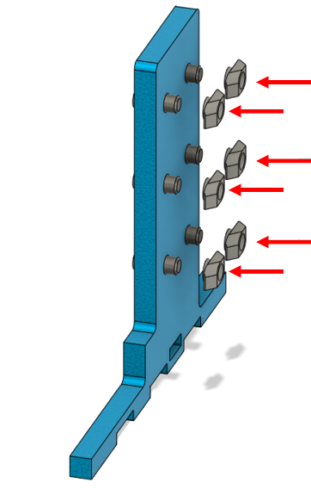

Place side plate with screws onto the linear actuator as pictured. Do not fully tighten the screws down yet.

Make sure there the base of the actuator is not fully flush with this tab cutout.

Insert Z bottom plate b into the tab as shown:

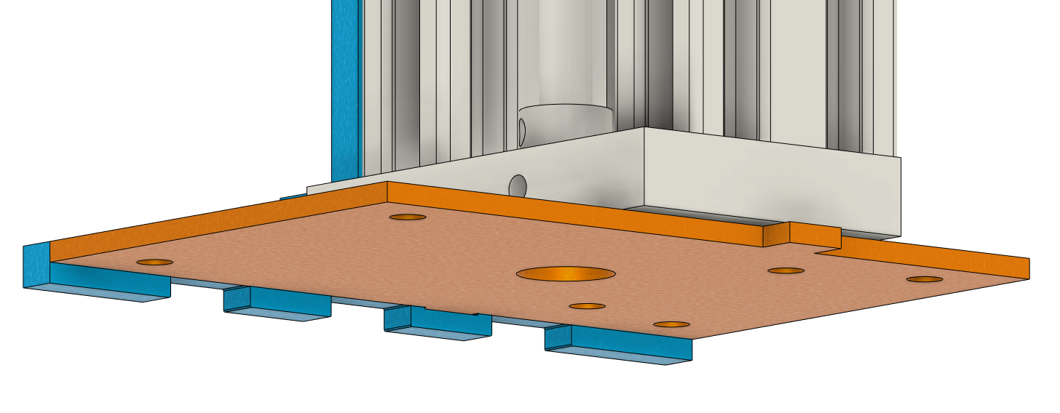

Apply thread locker to and insert the two M5x14mm screws through the Z bottom plate b as shown. Fully tighten these screws down to pull the linear actuator towards the plate.

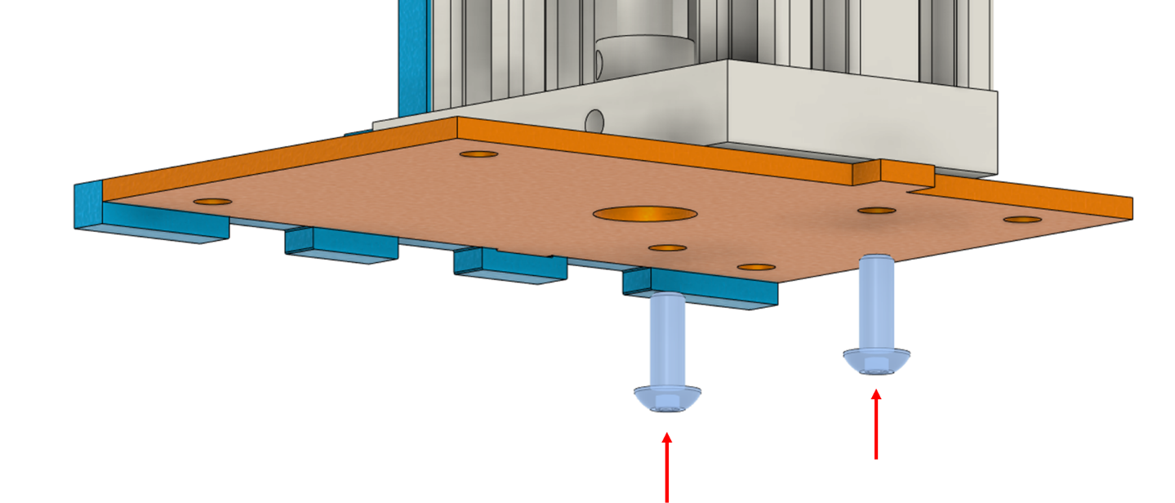

Tighten the six screws on the side of the installed Z-axis plate.

Assemble the remaining Z side plate as previously described, but with the orientation of the screw/nut assembly rotated, and install it on the other side of the actuator.

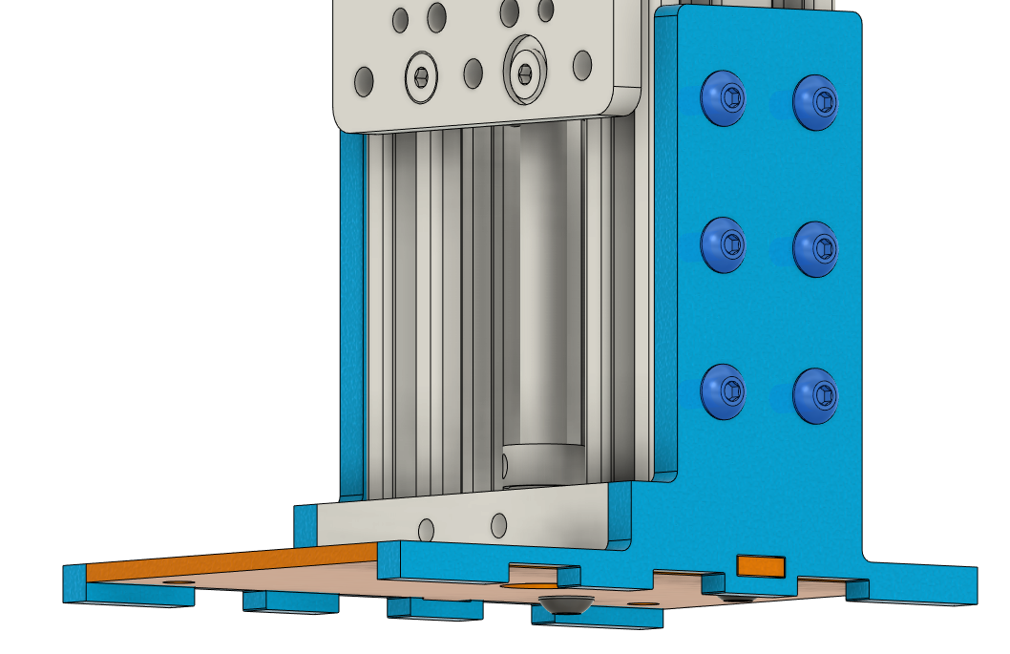

It may be desired to fill in any gaps between the Z bottom and side plate tabs with an adhesive. Apply a bead of gap filling cyanoacrylate adhesive (super glue) around the outside of the tab and allow glue to flow into the gaps before moving on. Region to apply glue is highlighted in green. If gap filling superglue is unavailable and only thin superglue is available, fill gap with baking soda and then soak with thin superglue.

Install Z bottom plate a as pictured below. It may be glued on with CA glue or epoxy. This is optional but recommended in order to keep the Z-axis mount together if future disassembly is needed.

